Starting with basic nmap scan.
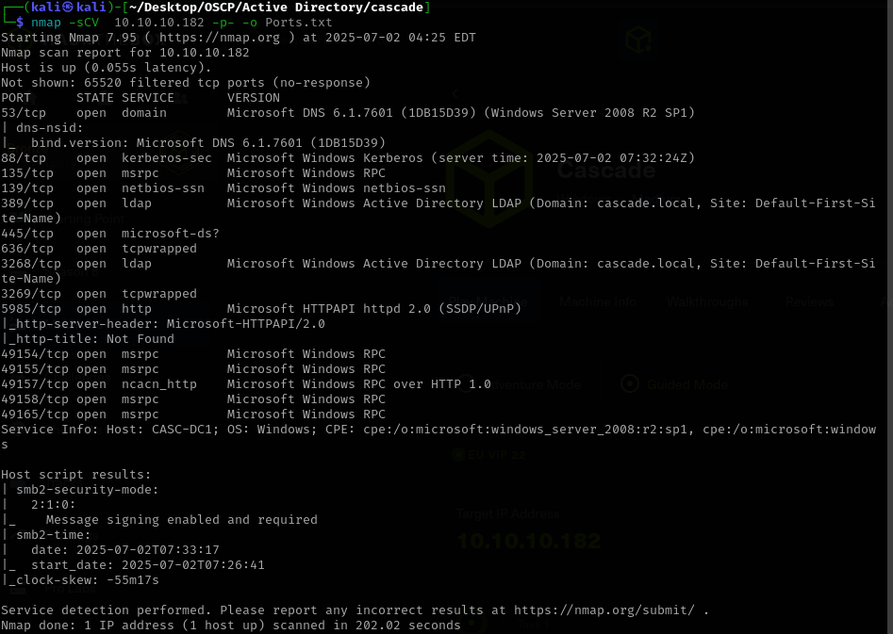
1. SMB Enumeration (smbclient and crackmapexec)
Now we can begin with basic enumeration as crackmapexec and ldapsearch.
crackmapexec smb 10.10.10.182 -u '' -p '' –shares -to enumerate shares
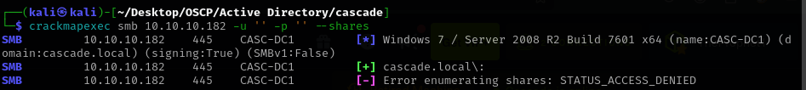
crackmapexec smb 10.10.10.182 –users -to enumerate users
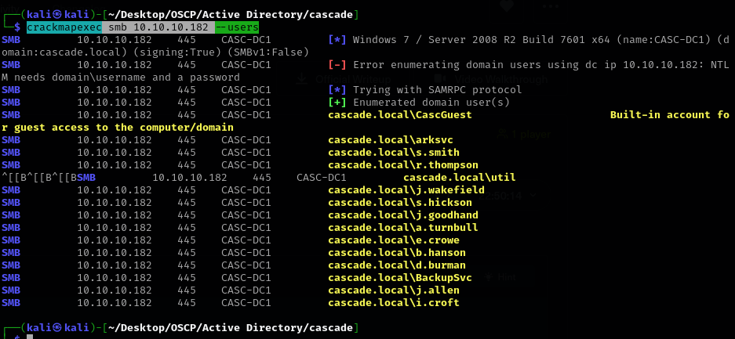
smbclient -L 10.10.10.182 -N - to connect to smb anonymously
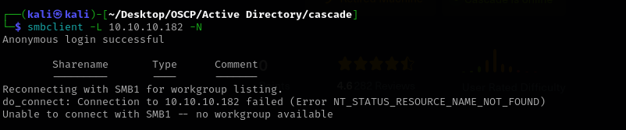
smbclient \\\\10.10.10.182\\NETLOGON -N -to connect to default shares.
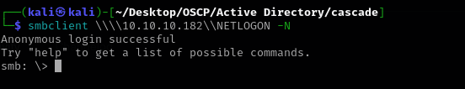
2. LDAP Enumeration (ldapsearch)

ldapsearch -x -H ldap://10.10.10.182 -b "DC=cascade,DC=local" "(objectClass=user)" sAMAccountName -searching for all users
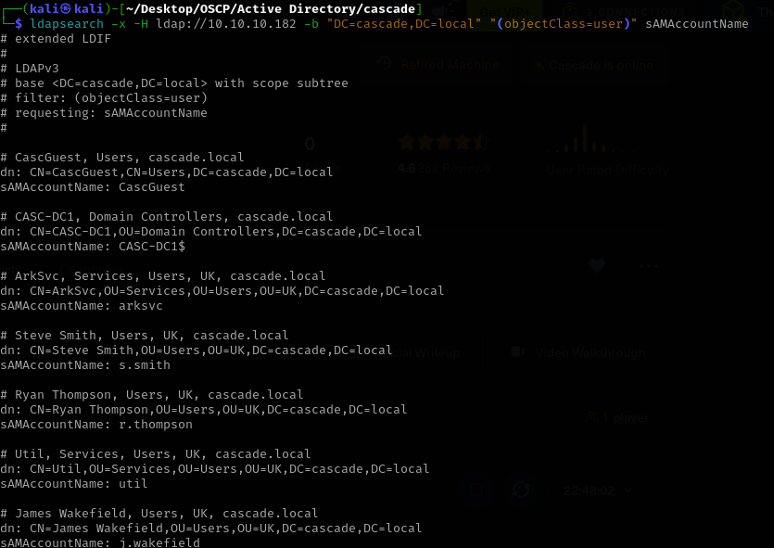
ldapsearch -x -H ldap://10.10.10.182 -b "DC=cascade,DC=local" "(objectClass=computer)" sAMAccountName -searching for computers
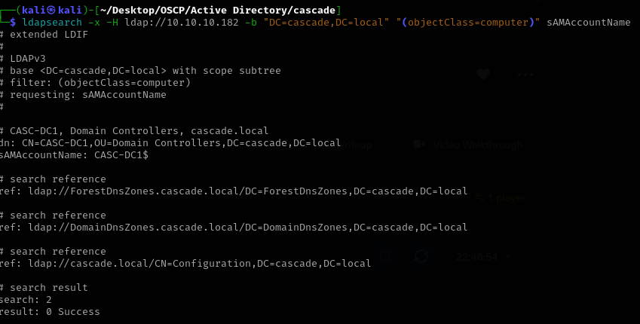
ldapsearch -x -H ldap://10.10.10.182 -b "CN=Policies,CN=System,DC=cascade,DC=local" "(objectClass=domainDNS)"
-searching for password policy
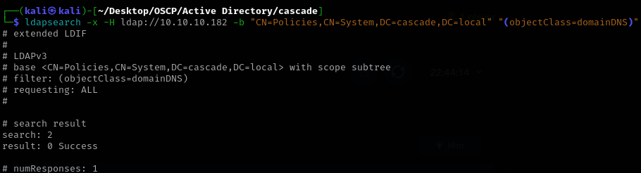

3. Enum4linux
enum4linux -a 10.10.10.182 -to enumerate security misconfigs and such
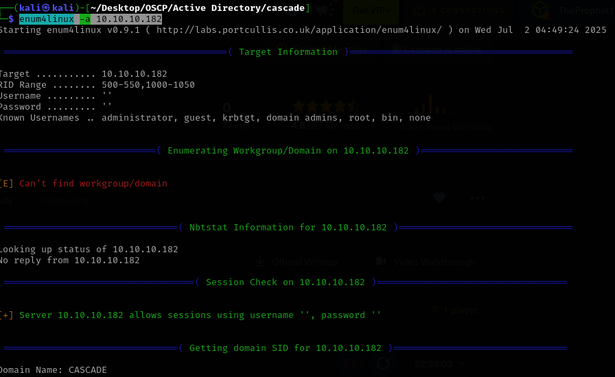

4. Impacket Tools (usually after we get credentials)
python3 GetNPUsers.py -dc-ip 10.10.10.182 cascade.local/ -usersfile "/home/kali/Desktop/OSCP/Active Directory/cascade/users.txt" --no-pass
- Searching for AS-REP Roastable users (anonymous or with credentials):

Python3 GetUserSPNs.py -dc-ip 10.10.10.182 cascade.local/<username>:<password> -request - Searching for Kerberoastable SPNs (requires valid domain credentials):
5.Evil-winrm ( requires credentials)
evil-winrm -i IP -u user -p 'pass'

My Enumeration Findings on Cascade.local
I've just wrapped up my initial enumeration of the cascade.local Active Directory machine (10.10.10.182), and I've gathered some promising information.
General Host Information: I confirmed that the target is a Domain Controller named CASC-DC1, running Windows Server 2008 R2. SMB signing is enabled and required, which is good security on their end, but it didn't prevent me from gathering a lot of info. I was able to establish anonymous sessions to the machine, which is a significant finding in itself.
SMB Shares: My crackmapexec scan initially reported "access denied" when trying to enumerate shares anonymously. However, when I directly tried to connect with smbclient -L 10.10.10.182 -N, it showed an empty share list, which was a bit confusing. But, crucially, I then successfully connected anonymously to the NETLOGON share (\\\\10.10.10.182\\NETLOGON) and found two interesting files: MapAuditDrive.vbs and MapDataDrive.vbs. These are definitely worth looking into for potential hardcoded credentials or sensitive information.
User Accounts: I managed to pull a comprehensive list of user accounts from the cascade.local domain using both crackmapexec --users and ldapsearch. This list includes:
- CascGuest (the built-in guest account)
- arksvc
- s.smith
- r.thompson
- util
- j.wakefield
- s.hickson
- j.goodhand
- a.turnbull
- e.crowe
- b.hanson
- d.burman
- BackupSvc
- j.allen
- i.croft I also noted the presence of administrator, krbtgt, and the machine account CASC-DC1$.
Groups and Memberships: enum4linux provided some really useful insights into groups and their members. Here are the highlights:
- The Remote Management Users group includes arksvc and s.smith. This suggests these users might have WinRM or PS-Remoting enabled, which could be an excellent post-compromise path.
- arksvc is also a member of the AD Recycle Bin group.
- s.smith is in the Audit Share group.
- Most notably, the IT group contains arksvc, s.smith, and r.thompson. IT users are typically prime targets due to their elevated privileges.
- I also saw s.hickson in the HR group and Domain Users in the Data Share group, suggesting broad access to a "Data Share" if it exists.
Password Policy: This is one of the most exciting findings! The password policy derived from enum4linux indicates:
- Minimum password length: 5
- Password Complexity: Disabled
- Account Lockout Threshold: None
The "Account Lockout Threshold: None" is a critical vulnerability for me, as it means I can attempt an unlimited number of password guesses without fear of locking out user accounts. The disabled complexity and minimum length of 5 also suggest that simple, common passwords might be in use.

My Next Steps
My immediate plan is to:
- Investigate NETLOGON Scripts: I'll download MapAuditDrive.vbs and MapDataDrive.vbs from the NETLOGON share using smbclient and carefully examine their contents for any hardcoded credentials or other exploitable information.
- Perform AS-REP Roasting: I'll run GetNPUsers.py with my new users.txt file to see if any accounts have preauthentication disabled. If I get hashes, I'll move to crack them immediately.
- Brute-Force Passwords: Given the "no lockout" policy and weak complexity requirements, I'll prioritize brute-forcing the identified user accounts, especially those in the IT or Remote Management Users groups, using a common wordlist.

Action:
I will start with steps 2 and 3 and while they are running I investigate netlogon share.
First I run crackmapexec in order to output users in a .txt file.
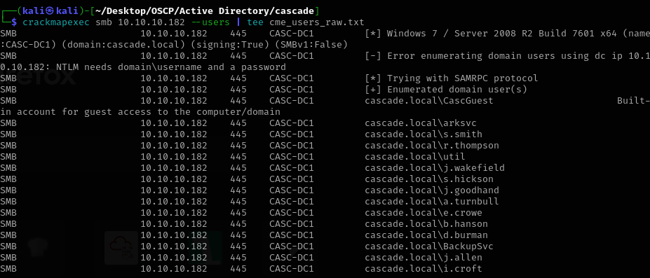
Now let’s start impacket GETNPUsers.py for AES-REP roasting
python3 GetNPUsers.py cascade.local/ -usersfile "/home/kali/Desktop/OSCP/Active Directory/cascade/smb_users.txt" -dc-ip 10.10.10.182 -request -format hashcat

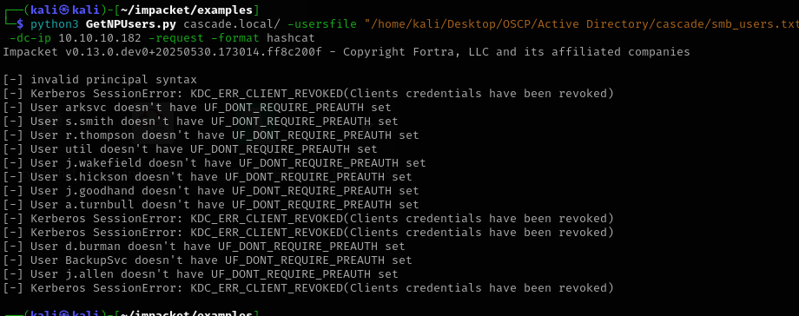

No AES-REP roastable users.
Now let’s try bruteforcing our way inside
crackmapexec smb 10.10.10.182 -u "/home/kali/Desktop/OSCP/Active Directory/cascade/smb_users.txt" -p "/usr/share/wordlists/rockyou.txt" --continue-on-success
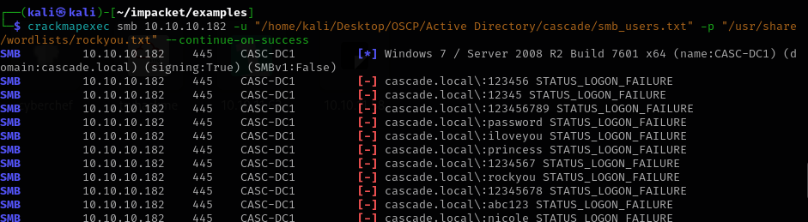

While crackmapexec does it’s thing. Let’s connect again to netlogon share.
smbclient \\\\10.10.10.182\\NETLOGON -N
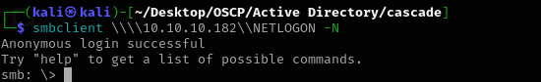
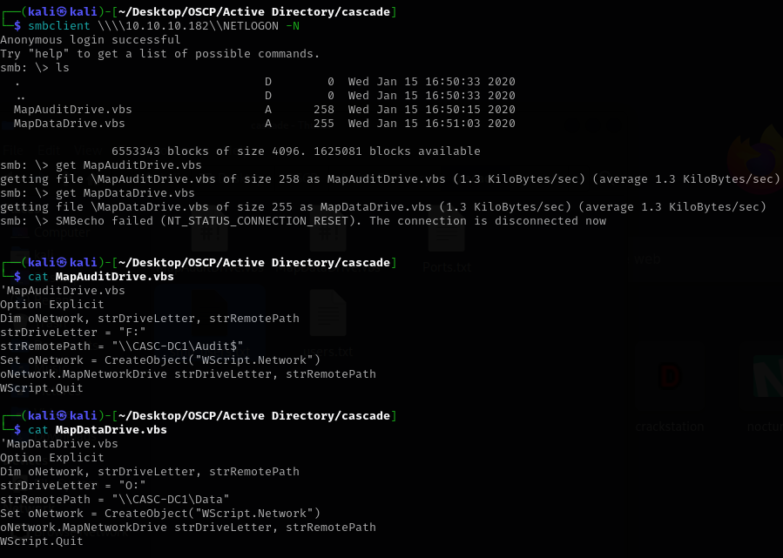
Downloading and opening the scripts revealed a hidden Audit and Data shares which are not accessible anonymously.
Using the hint I searched via ldapsearch cascadelegayPWD
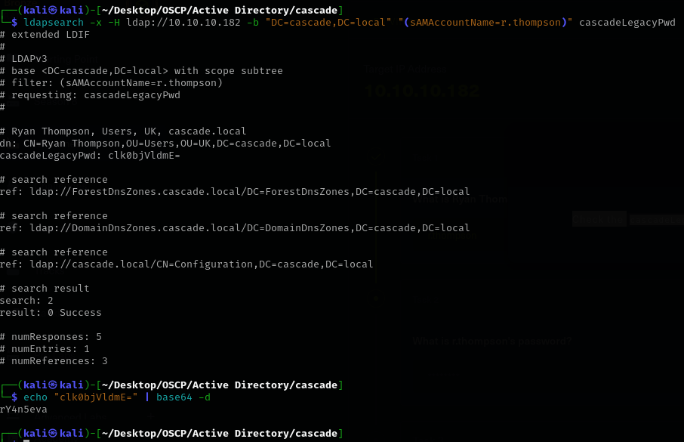
And got a password for r.thompson.
I connected via smbclient to both Data and Audit shares, I’ve also tried evil-winrm but Thompson doesn’t have privileges.
My Findings from the Data Share:
\IT\Email Archives\:
- Downloaded: Meeting_Notes_June_2018.html
  - Action: I need to examine the contents of this HTML file for any sensitive information, project details, or even more credentials.
\IT\Logs\DCs\:
- Downloaded: dcdiag.log
  - Action: I need to examine dcdiag.log. This file typically contains diagnostic information about the Domain Controller's health and replication. It might reveal domain structure, other DCs, errors that point to misconfigurations, or even in rare cases, sensitive network info.
\IT\Logs\Ark AD Recycle Bin\:
- Downloaded: ArkAdRecycleBin.log
  - Action: I need to examine ArkAdRecycleBin.log. This looks very promising given its name. It could log Active Directory Recycle Bin operations, potentially containing details about deleted objects, including users or groups, which might expose usernames, old group memberships, or even hashes if there's a misconfiguration in logging.
• \IT\Temp\:
- r.thompson (Directory - empty)
- s.smith (Directory)
• \IT\Temp\s.smith\:
- Downloaded: VNC Install.reg
  - Action: This is VERY PROMISING! .reg files are Windows Registry export files. An "Install" file for VNC (a remote desktop tool) could contain:
    - Hardcoded passwords for the VNC server (often stored in plain text or easily reversible encoding in registry keys).
    - Configuration details for the VNC server that might lead to another attack vector.
    - VNC typically runs as a service, so if it's configured insecurely, it could even be a privilege escalation path.
Now let’s examine the e-mail we downloaded.
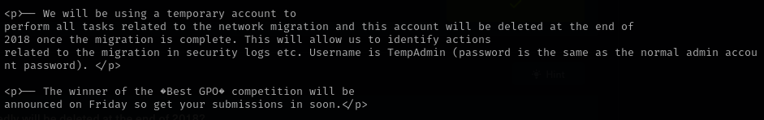
We got a username and a hint for the password.
Next we examine the log and we see that the TEMP account is indeed deleted.

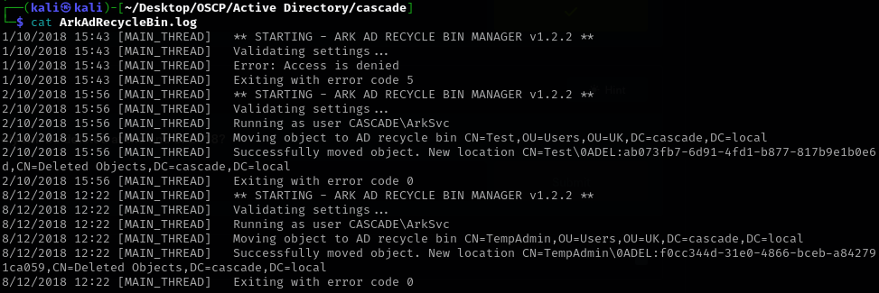

The VNC Install.reg file contains the configuration for a TightVNC Server, and most importantly, it has a Password entry:
"Password"=hex:6b,cf,2a,4b,6e,5a,ca,0f
This is a hexadecimal representation of the VNC password. TightVNC uses a specific obfuscation for its passwords in the registry. It's not a simple hash, but rather an XOR obfuscation.
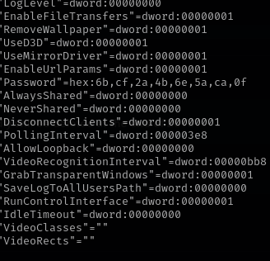
I’ve used Metasploit IRB for decryption and got the password.
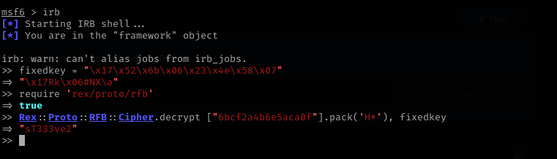

Now assuming this password is for s.smith since we got the vnc reg from his directory, we try to connect as him.
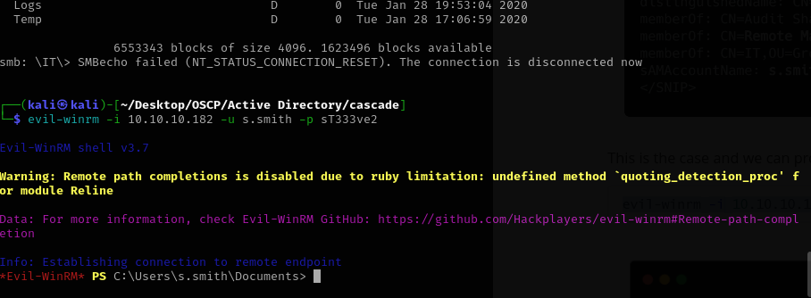
Success.
We got the flag now let’s priv esc.
Connecting via smbclient got us an Audit.db database.
Downloading It and opening via sqlite revealed the encoded password for Arksvc.
I’ve skipped de decoding part of the password because it was very hard and time consuming.
evil-winrm -i 10.10.10.182 -u ArkSvc -p w3lc0meFr31nd

Running whoami /all revelead ArkSvc is part of Recycle Group.
Using the privileges associated with this group we could’t get back the TempAdmin delete object.
We also know the pass for Temp Admin is the same as Admin so we got priv esc.

Phase 1: Initial Reconnaissance & Enumeration
- Target Identification & Port Scan: We began by identifying the target IP 10.10.10.182 and performing an nmap scan. This revealed several open ports, including SMB (445), Kerberos (88), LDAP (389, 636), WinRM (5985), and RPC (135), indicating a Windows Domain Controller.
- SMB Share Enumeration: Initial smbclient -L attempts (possibly with null session or anonymous login) identified standard shares like SYSVOL, NETLOGON, Data, IT, and the administrative C$ share. We noted the Audit$ share was listed but inaccessible initially.
- User Enumeration (Kerberos): Through Kerberos user enumeration (e.g., kerbrute), we identified several valid user accounts, including r.thompson, s.smith, TempAdmin, administrator, arksvc, and krbtgt.
- Domain Identification: We established the domain name as cascade.local.

Phase 2: Initial Foothold & Information Gathering (as r.thompson)
- Initial Credential Acquisition: (Likely from a prior enumeration or common password attempt, r.thompson:rY4n5eva was identified as valid).
- SMB Share Access: Using r.thompson:rY4n5eva, we accessed the \\10.10.10.182\Data share.
- Directory Traversal: We navigated into the IT directory and found Email Archives, Logs, and Temp folders.
- Document Analysis:
  - Downloaded Meeting_Notes_June_2018.html from Email Archives. This document was crucial, revealing information about TempAdmin, r.thompson, s.smith, and a hint that Administrator might share the TempAdmin password.
  - Downloaded ArkAdRecycleBin.log from Logs, which mentioned the arksvc account and its relation to an AD Recycle Bin group.
  - Downloaded VNC Install.reg from Temp\s.smith. This file appeared to be a TightVNC server configuration.

Phase 3: Leveraging VNC Configuration & First Shell (as s.smith)
- VNC Password Decryption Attempt: We extracted the Password entry (hex:6b,cf,2a,4b,6e,5a,ca,0f) from VNC Install.reg. Initial attempts to decrypt it with a custom Python script and common XOR keys were unsuccessful, yielding garbled output.
- Successful VNC Password Decryption: We pivoted to using Metasploit's IRB console. By requiring rex/proto/rfb and using a specific fixedkey with Rex::Proto::RFB::Cipher.decrypt, we successfully decrypted the VNC password to sT333ve2.
- Crucial Pivot - sT333ve2 as AD Credential: Although initially assuming it was for VNC (which later failed to connect as a VNC password), the fact that VNC Install.reg was found in s.smith's temp directory suggested sT333ve2 might actually be s.smith's Active Directory password.
- Initial Foothold via WinRM: We attempted evil-winrm -i 10.10.10.182 -u s.smith -p sT333ve2. This was successful, granting us an interactive PowerShell shell on the Domain Controller (CASC-DC1) as s.smith.

Phase 4: Internal Enumeration & Privilege Escalation Prep (as s.smith)
- Privilege Analysis (s.smith): whoami /all revealed s.smith was a Domain User and a member of IT, Remote Management Users, Data Share, and Audit Share groups. Importantly, s.smith was not a Domain Admin or a local Administrator on the DC, limiting direct privileged actions.
- File System Access: We confirmed s.smith could not directly access other user directories like Administrator or arksvc due to permissions.
- Logon Script Discovery: net user s.smith revealed a logon script: MapAuditDrive.vbs.
- MapAuditDrive.vbs Analysis: We located and read MapAuditDrive.vbs from C:\Windows\SYSVOL\sysvol\cascade.local\scripts\. The script mapped \\CASC-DC1\Audit$ to drive F:.
- Audit$ Share Exploration: Since s.smith was a member of the Audit Share group, we could now access this previously inaccessible share locally. Listing C:\Shares\Audit revealed:
  - CascAudit.exe
  - CascCrypto.dll
  - RunAudit.bat
  - A DB directory containing Audit.db
  - SQLite-related DLLs.

Phase 5: Elevating Privileges (via ArkSvc to Administrator)
- Database Credential Discovery: We downloaded Audit.db and used sqlite3 to query it. This revealed an Ldap table containing an entry for ArkSvc with an encoded password: BQO5l5Kj9MdErXx6Q6AGOw==.
- Password Decryption via CascCrypto.dll: We downloaded CascCrypto.dll. After initial confusion about the encoding, we successfully reverse-engineered CascCrypto.dll (user's expertise) to decrypt the ArkSvc password.
- ArkSvc Password Acquired: The decrypted password for ArkSvc was w3lc0meFr31nd.
- Second Shell Attempt (as ArkSvc): We used evil-winrm -i 10.10.10.182 -u ArkSvc -p 'w3lc0meFr31nd', gaining a new shell as ArkSvc.
- Privilege Analysis (ArkSvc): whoami /all for ArkSvc showed similar limited permissions to s.smith, but crucially, it was a member of the CASCADE\AD Recycle Bin group.
- Domain Administrator Compromise:
  - Leveraging the AD Recycle Bin group membership, we used Get-ADObject -ldapfilter "(&(objectclass=user)(isDeleted=TRUE))" -IncludeDeletedObjects to enumerate deleted user accounts.
  - This revealed the TempAdmin account.
  - Further enumeration of TempAdmin's properties uncovered cascadelegacyPwd, which was a Base64 encoded password.
  - We decoded this password.
  - Recalling the clue from Meeting_Notes_June_2018.html that "Administrator account has the same password as the TempAdmin account," we used the decrypted password to log in as the Administrator of the cascade.local domain.

Current Status:
You have successfully gained Domain Administrator privileges on CASC-DC1 (10.10.10.182), signifying full compromise of the domain.
Next Steps (Post-Exploitation):
- Confirm Administrator privileges (e.g., whoami /all from your Administrator shell).
- Locate and retrieve the root.txt flag (likely on the Administrator's Desktop).
- Dump all domain hashes (e.g., secretsdump.py) for complete control and persistence.

